|  |
| --- |
| **Projets PFE** |
|  |

# CHRONOLOGIE DU DOCUMENT

|  |  |  |  |
| --- | --- | --- | --- |
| **Stagiaire/Collaborateur** | **Action** | **Date** | **Version** |
| ES-SAMERY ABDELOUADOUD | Livraison du rapport | 27/03/2020 | 1.0 |

# INTITULE DU PROJET :

|  |  |  |  |  |
| --- | --- | --- | --- | --- |
| **Titre du projet :** | | | | |
| **Pôle** | **Encadrant** | **Co-Encadrant** | **Stagiaire** | **Date de début** |
| BIG DATA | Lamalem Nizar | Haitam El Maaloumi | ES-SAMERY Abdelouadoud | 02/03/2020 |

# DESCRIPTION DU PROJET :

Search Engines are one of the most used tools in internet like Google, they are based on bots called spiders that crawl the internet, extract and index useful information, existing engines use **keyword matching** or **tf-idf** based matching to map the query to the web-documents and rank them; however they do not perform well if the query becomes too big and complex.

This Project “**Searchy**” is an improvement of classical search engines; it is an intelligent engine that uses machine learning and deep learning techniques to give more performances and reliable results. This is reachable thanks to the **Google Bert Algorithm** through understanding not only the syntax of sentence but the context of a word in the query which makes it in purpose of fully and give more related results based on it.

# L'ARCHITECTURE FONCTIONNELLE/TECHNIQUE :

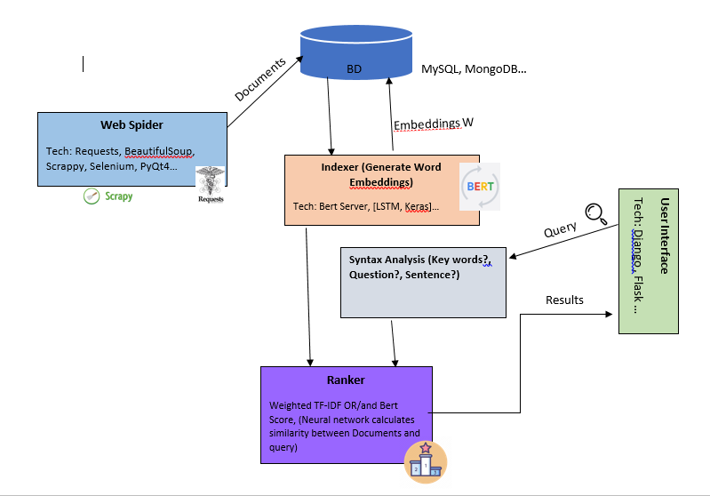

**WorkFlow of the Project**

# DIAGRAMME DE GANTT :

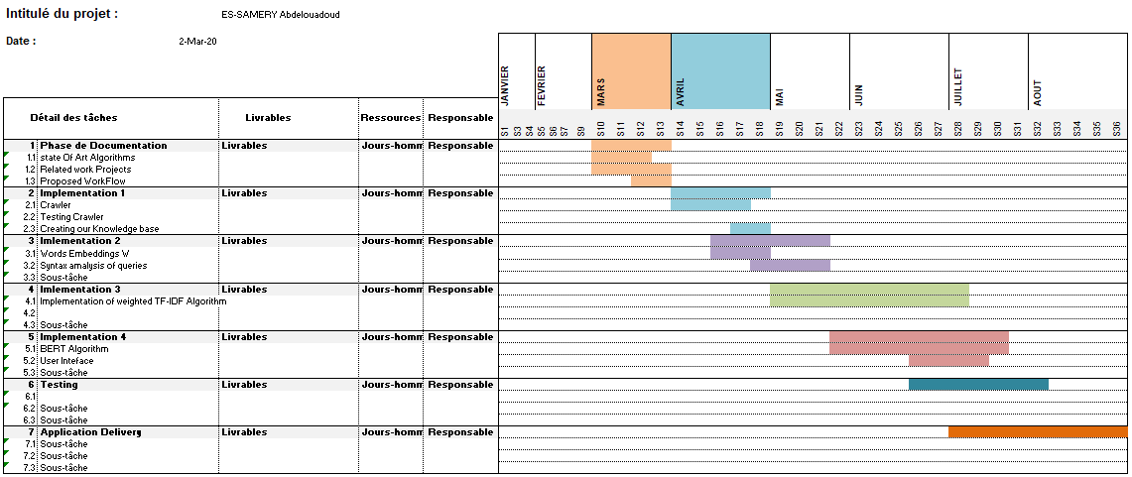

**Gantt Diagram**

# PLANIFICATION DES ACTIVITES :

|  |  |  |
| --- | --- | --- |
| **Activité** | **Livrable(s)** | **Date prévue de livraison** |
| Report and proposed workflow | Report | 27/03/2020 |
| Implementation 1 : Crawler | Code |  |
| Implementation 2 : Word Embeddings, syntax Analysis | Code (+ report) |  |
| Implementation 3 : weighted TF-IDF | Code |  |
| Implementation 4 : Bert Algorithm, UserInterface | Code (+ report) |  |
| Testing | Report |  |
| Application Delivery | Code + Report |  |

# AVANCEMENT DES TRAVAUX :

|  |  |  |  |
| --- | --- | --- | --- |
| **Semaine** | **Activités Réalisées/En cours** | **Avancement** | **Estimation en J/H** |
| **23 au 27/03/2020** | Reading Resarch paper on StateOfArt Algorithms for Ranking | 80% | 4j |
| Reading Research Project on weighted TFIDF and Bert Algorithm | 90% | 4j |
| Reading these papers on DL Models and NLP representations | 80% | 4j |
| Looking for more Github Projects related | 95% | 4j |
| Django tutorial (en cours) | 35% | 2j |
| Proposed Workflow | 100% | 2j |

# LIVRABLES REALISES :

|  |  |
| --- | --- |
| **Livrable I** | **Report Of The Week (23 au 27/03/2020)** |
| **Livrable II** |  |
| **Livrable N** |  |